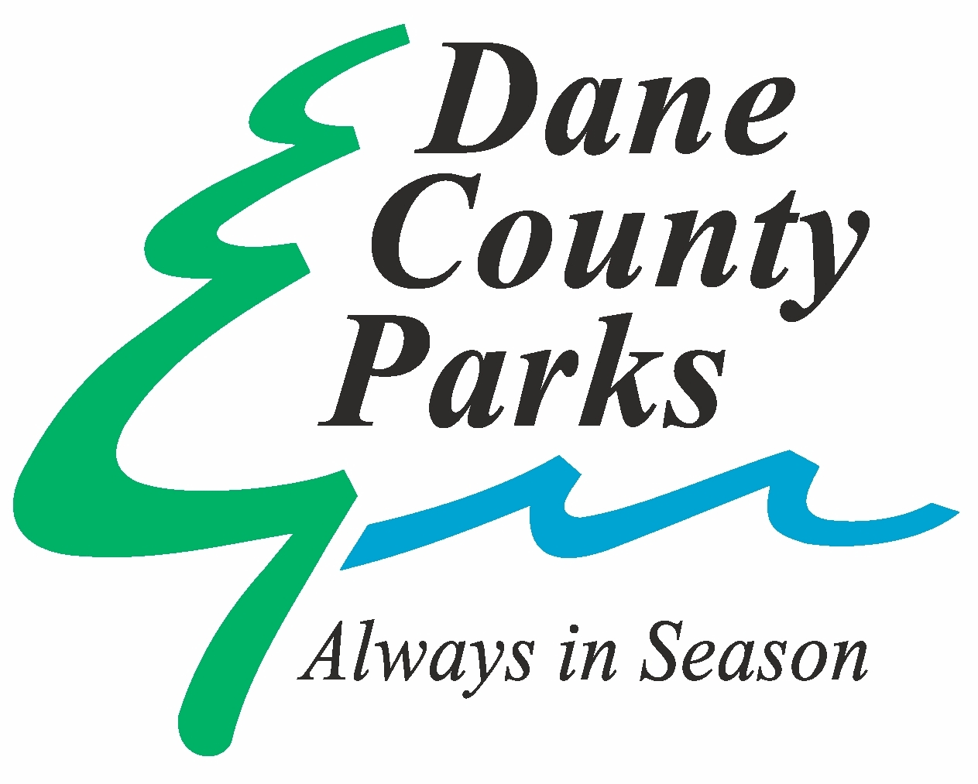
This grant application will be viewed by all granting entities. One application will allow your proposal to be considered for multiple awards. Please fill out each field as much as possible to be considered for the various grant programs. Refer to the attached criteria to ensure all documentation is included.

Applications are due by 4:30 pm on August 2, 2021
By email to extension@countyofdane.com or mail to Dane County Extension 5201 Fen Oak Dr. STE 138 Madison, WI 53718
2021 Grant Application

Project Title |  | Organization
Project Timeline |  | Fiscal Agent  if different from organization
Which would your organization be classified as?  Check all that apply | Friends of Dane County Parks  Municipality  501(c)3  School or School District  Other:  __________________________
Are you able to provide the match if requested? | Equipment rental or purchase  No  Yes  If so, how much?  __________________________
What is the main purpose for the grant?  Check all that apply | Native Plant Request  Environmental/Sustainability Education or Interpretation  Park Construction or Restoration Project  Other:  __________________________  Volunteerism
Will you accept partial funding of this request? | No  Yes | Will the project move forward without this funding? | No  Yes

Authorized Project Representative Contact Information
Name
Title
Organization Address |  | Street
 |  | State and Zip
Phone | Work |  |  |  | Cell
Email

Proposal Narrative (Maximum 1000 words)

Project Budget Form

Applicant Name: | Project Name: |  |  |  |  | Sources of Funding
ITEM DESCRIPTION  (List ALL project components) | Quantity | Unit Cost |  | Total |  | Matching &  In-kind Funds |  | Grant Funds  Requested
 |  |  | TOTAL  PROJECT  COST |  |  | TOTAL  MATCHING  FUNDS | TOTAL  GRANT  FUNDS  REQUESTED

Tips for a good budget:
- Be sure to review the grant program requirements carefully
- Sources of matching funds are required for capital grants
- Use county living wage for non-professional volunteer time - $15 per hour
- Provide details (model numbers, quantity, vendors, etc.)
- Two estimates are required for any single item (including contract work) or multiples of a single item with a total value over $250. Bids must be on bidder’s official letterhead. With bids, check for non-profit pricing for items.

Once grant is approved, no budget changes may be made without prior approval.
NATIVE PLANT REQUEST

Community Group or School Affiliation:________________________________________________________

Project Location (approx. address):____________________________________________________________

How many plants* would you like?: ___________________________________________________________
(*A good rule of thumb is one plant for every 1-1.5 square feet)

Does this project include a rain garden? Yes No
Are you interested in educational signage to post at this garden? Yes No
Check one: This will be a new garden We are enhancing an existing garden

Brief description of the project and how the plants will be used? If the plants are part of a larger project in this grant application, describe how they fit into the larger project.

Are you working with a professional landscaper or native plant expert to design your garden? If so, who are you working with?

Who will maintain the garden after it is planted (watering, weeding, etc.)? Who will maintain the garden long-term?

If your project is approved, we will follow up with you about plant selection. By completing this section of the grant application, you are agreeing that if you receive plants you will:
- Use the plants for the purpose described on the application
- Water and care for the plants during the first few years while their roots are becoming established.
- Provide a short write up and photos to Dane County after the project is complete.

